

**REPORT MANUAL OF JOBSHEET**

**Practicum, Tasks and Questions**

**(Network Programming)**

|  |  |  |  |  |
| --- | --- | --- | --- | --- |
|  | **Name** | **:** | **Brian Sayudha** |  |
|  | **Class / NIM** | **:** | **3G / 1841720158** |  |
|  | **Major** | **:** | **D-IV Informatics Enginering** |  |
|  |  |  |  |  |
|  |  |  |  |  |

Praktikum 1

Code

/*

 * To change this license header, choose License Headers in Project Properties.

 * To change this template file, choose Tools | Templates

 * and open the template in the editor.

 */

package *J*obsheet5;

import java.io.FileInputStream;

import java.io.FileNotFoundException;

import java.io.IOException;

import java.io.LineNumberInputStream;

import java.util.logging.Logger;

import java.util.logging.Level;

/**

 *

 * @author Asus

 */

public class ReadFile {

    public static *void* main(*String*[] *args*) {

        try {

*int* desimal;

*char* ascii;

*LineNumberInputStream* inputStream = **new** LineNumberInputStream(**new** FileInputStream("coba.txt"));

             while ((desimal = inputStream.read()) != -1) {

                 ascii = (*char*) desimal;

                 System.out.println("" + ascii + " at line " + inputStream.getLineNumber());

             }

         } catch (*FileNotFoundException* *ex*) {

             Logger.getLogger(ReadFile.class.getName()).log(Level.SEVERE, null, ex);

         } catch (*IOException* *ex*) {

             Logger.getLogger(ReadFile.class.getName()).log(Level.SEVERE, null, ex);

         }

    }

}

Result

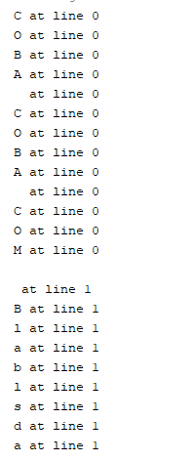

QUESTION PRAK 1

Modify the above program so that it can do the following

* Asks for the location of the file you created, the file location is input via the keyboard.

Code

/*

 * To change this license header, choose License Headers in Project Properties.

 * To change this template file, choose Tools | Templates

 * and open the template in the editor.

 */

package *J*obsheet5;

import java.io.FileInputStream;

import java.io.FileNotFoundException;

import java.io.IOException;

import java.io.LineNumberInputStream;

import java.util.Scanner;

import java.util.logging.Logger;

import java.util.logging.Level;

/**

 *

 * @author Asus

 */

public class ReadFile {

    public static *void* main(*String*[] *args*) {

        try {

*int* desimal;

*char* ascii;

*Scanner* sc = **new** Scanner(System.in);

            System.out.println("Input The File Destination");

            System.out.println("For Example : E:/TUGAS/Jarkom/Semester 5/Stream/JavaLibrary5/Coba.txt");

            System.out.println("Destination : ");

*String* input = sc.nextLine();

*LineNumberInputStream* inputStream = **new** LineNumberInputStream(**new** FileInputStream(input));

            while ((desimal = inputStream.read()) != -1) {

                ascii = (*char*) desimal;

                System.out.println("" + ascii + " at line " + inputStream.getLineNumber());

            }

        } catch (*FileNotFoundException* *ex*) {

            Logger.getLogger(ReadFile.class.getName()).log(Level.SEVERE, null, ex);

        } catch (*IOException* *ex*) {

            Logger.getLogger(ReadFile.class.getName()).log(Level.SEVERE, null, ex);

        }

    }

}

RESULT

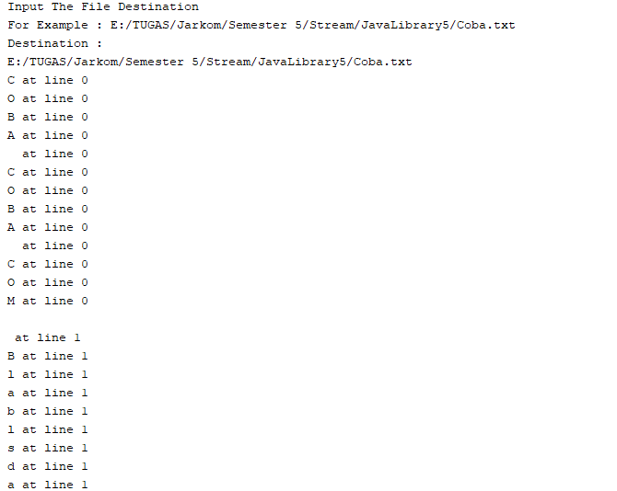

* Displays the number of lines in a file!

Code

/*

 * To change this license header, choose License Headers in Project Properties.

 * To change this template file, choose Tools | Templates

 * and open the template in the editor.

 */

package *J*obsheet5;

import java.io.FileInputStream;

import java.io.FileNotFoundException;

import java.io.IOException;

import java.io.LineNumberInputStream;

import java.util.Scanner;

import java.util.logging.Logger;

import java.util.logging.Level;

/**

 *

 * @author Asus

 */

public class ReadFile {

    public static *void* main(*String*[] *args*) {

        try {

*int* desimal;

*char* ascii;

*int* paragraph = 1;

*Scanner* sc = **new** Scanner(System.in);

            System.out.println("Input The File Destination");

            System.out.println("For Example : E:/TUGAS/Jarkom/Semester 5/Stream/JavaLibrary5/Coba.txt");

            System.out.println("Destination : ");

*String* input = sc.nextLine();

*LineNumberInputStream* inputStream = **new** LineNumberInputStream(**new** FileInputStream(input));

            while ((desimal = inputStream.read()) != -1) {

                ascii = (*char*) desimal;

                System.out.println("" + ascii + " at line " + inputStream.getLineNumber());

            }

            paragraph += inputStream.getLineNumber();

            System.out.println("\nLines total : " + paragraph);

        } catch (*FileNotFoundException* *ex*) {

            Logger.getLogger(ReadFile.class.getName()).log(Level.SEVERE, null, ex);

        } catch (*IOException* *ex*) {

            Logger.getLogger(ReadFile.class.getName()).log(Level.SEVERE, null, ex);

        }

    }

}

RESULT

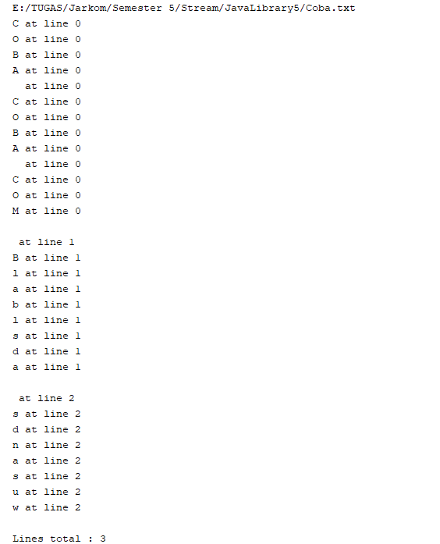

* Searching for the line location of a specified character, characters are input via the keyboard

Code

/*

 * To change this license header, choose License Headers in Project Properties.

 * To change this template file, choose Tools | Templates

 * and open the template in the editor.

 */

package *J*obsheet5;

import java.io.FileNotFoundException;

import java.io.FileReader;

import java.io.IOException;

import java.io.LineNumberReader;

import java.util.Scanner;

import java.util.logging.Logger;

import java.util.logging.Level;

/**

 *

 * @author Asus

 */

public class ReadFileReader {

    public static *void* main(*String*[] *args*) {

        try {

*int* desimal;

*char* ascii;

*LineNumberReader* lineNumberReader = **new** LineNumberReader(**new** FileReader("Coba.txt"));

                 while ((desimal = lineNumberReader.read()) != -1) {

                     ascii = (*char*) desimal;

                     System.out.println("" + ascii + " at line " + lineNumberReader.getLineNumber());

                 }

             } catch (*FileNotFoundException* *ex*) {

                 Logger.getLogger(ReadFileReader.class.getName()).log(Level.SEVERE, null, ex);

             } catch (*IOException* *ex*) {

                 Logger.getLogger(ReadFileReader.class.getName()).log(Level.SEVERE, null, ex);

             }

    }

}

RESULT

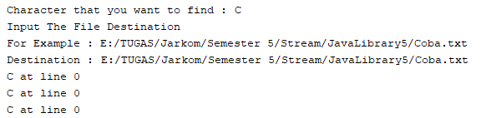

Praktikum 2

/*

 * To change this license header, choose License Headers in Project Properties.

 * To change this template file, choose Tools | Templates

 * and open the template in the editor.

 */

package *J*obsheet5;

import java.io.FileNotFoundException;

import java.io.FileReader;

import java.io.IOException;

import java.io.LineNumberReader;

import java.util.logging.Logger;

import java.util.logging.Level;

/**

 *

 * @author Asus

 */

public class ReadFileReader {

    public static *void* main(*String*[] *args*) {

        try {

*int* desimal;

*char* ascii;

*LineNumberReader* lineNumberReader = **new** LineNumberReader(**new** FileReader("coba.txt"));

                 while ((desimal = lineNumberReader.read()) != -1) {

                     ascii = (*char*) desimal;

                     System.out.println("" + ascii + " at line " + lineNumberReader.getLineNumber());

                 }

             } catch (*FileNotFoundException* *ex*) {

                 Logger.getLogger(ReadFileReader.class.getName()).log(Level.SEVERE, null, ex);

             } catch (*IOException* *ex*) {

                 Logger.getLogger(ReadFileReader.class.getName()).log(Level.SEVERE, null, ex);

             }

    }

}

RESULT

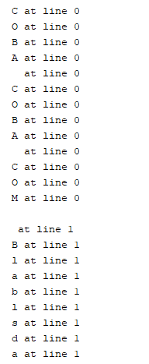

QUESTION PRAK 2

Change the code above so that it can do the following

* Tells which line a word is on

/*

 * To change this license header, choose License Headers in Project Properties.

 * To change this template file, choose Tools | Templates

 * and open the template in the editor.

 */

package *J*obsheet5;

import java.io.FileNotFoundException;

import java.io.FileReader;

import java.io.IOException;

import java.io.LineNumberReader;

import java.util.Scanner;

import java.util.logging.Logger;

import java.util.logging.Level;

/**

 *

 * @author Asus

 */

public class ReadFileReader {

    public static *void* main(*String*[] *args*) {

        try {

*int* countword;

*char* ascii;

*String* word;

*LineNumberReader* lineNumberReader = **new** LineNumberReader(**new** FileReader("Coba.txt"));

                 while ((word = lineNumberReader.readLine()) != null) {

*String*[] wording = word.split("\\s+");

                     System.out.println("" + word + " at line " + lineNumberReader.getLineNumber());

                 }

             } catch (*FileNotFoundException* *ex*) {

                 Logger.getLogger(ReadFileReader.class.getName()).log(Level.SEVERE, null, ex);

             } catch (*IOException* *ex*) {

                 Logger.getLogger(ReadFileReader.class.getName()).log(Level.SEVERE, null, ex);

             }

    }

}

RESULT

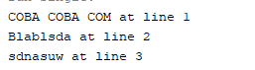

* Count the number of words

Code

/*

 * To change this license header, choose License Headers in Project Properties.

 * To change this template file, choose Tools | Templates

 * and open the template in the editor.

 */

package *J*obsheet5;

import java.io.FileNotFoundException;

import java.io.FileReader;

import java.io.IOException;

import java.io.LineNumberReader;

import java.util.Scanner;

import java.util.logging.Logger;

import java.util.logging.Level;

/**

 *

 * @author Asus

 */

public class ReadFileReader {

    public static *void* main(*String*[] *args*) {

        try {

*int* countword = 0;

*char* ascii;

*String* word;

*LineNumberReader* lineNumberReader = **new** LineNumberReader(**new** FileReader("Coba.txt"));

                 while ((word = lineNumberReader.readLine()) != null) {

*String*[] wording = word.split("\\s+");

                     System.out.println("" + word + " at line " + lineNumberReader.getLineNumber());

                     countword += wording.length;

                 }

                 System.out.println("Word Count : " + countword);

             } catch (*FileNotFoundException* *ex*) {

                 Logger.getLogger(ReadFileReader.class.getName()).log(Level.SEVERE, null, ex);

             } catch (*IOException* *ex*) {

                 Logger.getLogger(ReadFileReader.class.getName()).log(Level.SEVERE, null, ex);

             }

    }

}

RESULT

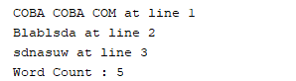

* Count the number of characters

Code

/*

 * To change this license header, choose License Headers in Project Properties.

 * To change this template file, choose Tools | Templates

 * and open the template in the editor.

 */

package *J*obsheet5;

import java.io.FileNotFoundException;

import java.io.FileReader;

import java.io.IOException;

import java.io.LineNumberReader;

import java.util.Scanner;

import java.util.logging.Logger;

import java.util.logging.Level;

/**

 *

 * @author Asus

 */

public class ReadFileReader {

    public static *void* main(*String*[] *args*) {

        try {

*int* countword = 0;

*char* ascii;

*String* word;

*int* countchar = 0;

*LineNumberReader* lineNumberReader = **new** LineNumberReader(**new** FileReader("Coba.txt"));

                 while ((word = lineNumberReader.readLine()) != null) {

*String*[] wording = word.split("\\s+");

                     System.out.println("" + word + " at line " + lineNumberReader.getLineNumber());

                     countword += wording.length;

                     countchar += word.length();

                 }

                 System.out.println("Word Count : " + countword);

                 System.out.println("Character Count : " + countchar);

             } catch (*FileNotFoundException* *ex*) {

                 Logger.getLogger(ReadFileReader.class.getName()).log(Level.SEVERE, null, ex);

             } catch (*IOException* *ex*) {

                 Logger.getLogger(ReadFileReader.class.getName()).log(Level.SEVERE, null, ex);

             }

    }

}

Result

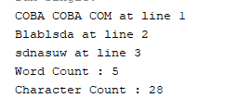

Assignment

Design

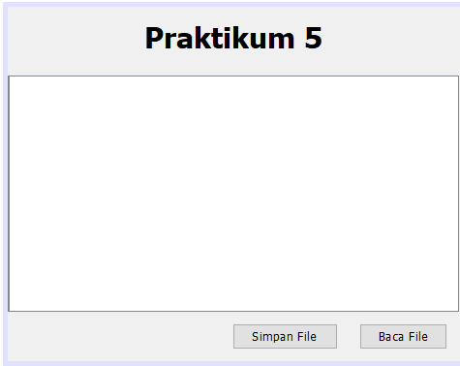

Code design

/*

 * To change this license header, choose License Headers in Project Properties.

 * To change this template file, choose Tools | Templates

 * and open the template in the editor.

 */

package *J*obsheet5;

import javax.swing.JButton;

import javax.swing.JFileChooser;

import javax.swing.JTextPane;

/**

 *

 * @author Asus

 */

public class tugas extends javax.swing.*JFrame* {

    /**

     * Creates new form tugas

     */

     private *TugasController* controller;

     public tugas() {

         initComponents();

         controller = **new** TugasController(*this*);

     }

    public *JButton* getjButtonBaca() {

        return jButtonBaca;

    }

    public *JTextPane* getjTextPane() {

        return jTextPane;

    }

    public *JFileChooser* getLoadFile() {

        return loadFile;

    }

    public *JButton* getjButtonSimpan() {

        return jButtonSimpan;

    }

    /**

     * This method is called from within the constructor to initialize the form.

     * WARNING: Do NOT modify this code. The content of this method is always

     * regenerated by the Form Editor.

     */

    @*SuppressWarnings*("unchecked")

    // <editor-fold defaultstate="collapsed" desc="Generated Code">

    private *void* initComponents() {

        loadFile = **new** javax.swing.JFileChooser();

        jLabel1 = **new** javax.swing.JLabel();

        jScrollPane1 = **new** javax.swing.JScrollPane();

        jTextPane = **new** javax.swing.JTextPane();

        jButtonBaca = **new** javax.swing.JButton();

        jButtonSimpan = **new** javax.swing.JButton();

        setDefaultCloseOperation(javax.swing.WindowConstants.EXIT_ON_CLOSE);

        jLabel1.setFont(**new** java.awt.Font("Tahoma", 1, 24)); // NOI18N

        jLabel1.setText("Praktikum 5");

        jScrollPane1.setViewportView(jTextPane);

        jButtonBaca.setText("Baca File");

        jButtonBaca.addActionListener(**new** java.awt.event.ActionListener() {

            public *void* actionPerformed(java.awt.event.ActionEvent evt) {

                jButtonBacaActionPerformed(evt);

            }

        });

        jButtonSimpan.setText("Simpan File");

        jButtonSimpan.addActionListener(**new** java.awt.event.ActionListener() {

            public *void* actionPerformed(java.awt.event.ActionEvent evt) {

                jButtonSimpanActionPerformed(evt);

            }

        });

*javax*.*swing*.*GroupLayout* layout = **new** javax.swing.GroupLayout(getContentPane());

        getContentPane().setLayout(layout);

        layout.setHorizontalGroup(

            layout.createParallelGroup(javax.swing.GroupLayout.Alignment.LEADING)

            .addComponent(jScrollPane1, javax.swing.GroupLayout.Alignment.TRAILING)

            .addGroup(javax.swing.GroupLayout.Alignment.TRAILING, layout.createSequentialGroup()

                .addContainerGap(javax.swing.GroupLayout.DEFAULT_SIZE, Short.MAX_VALUE)

                .addComponent(jButtonSimpan)

                .addGap(18, 18, 18)

                .addComponent(jButtonBaca)

                .addContainerGap())

            .addGroup(layout.createSequentialGroup()

                .addGap(112, 112, 112)

                .addComponent(jLabel1)

                .addContainerGap(114, Short.MAX_VALUE))

        );

        layout.setVerticalGroup(

            layout.createParallelGroup(javax.swing.GroupLayout.Alignment.LEADING)

            .addGroup(layout.createSequentialGroup()

                .addContainerGap()

                .addComponent(jLabel1)

                .addGap(18, 18, 18)

                .addComponent(jScrollPane1, javax.swing.GroupLayout.PREFERRED_SIZE, 195, javax.swing.GroupLayout.PREFERRED_SIZE)

                .addPreferredGap(javax.swing.LayoutStyle.ComponentPlacement.UNRELATED)

                .addGroup(layout.createParallelGroup(javax.swing.GroupLayout.Alignment.BASELINE)

                    .addComponent(jButtonBaca)

                    .addComponent(jButtonSimpan))

                .addContainerGap(javax.swing.GroupLayout.DEFAULT_SIZE, Short.MAX_VALUE))

        );

        pack();

    }// </editor-fold>

    private *void* jButtonBacaActionPerformed(*java*.*awt*.*event*.*ActionEvent* *evt*) {

        // TODO add your handling code here:

    }

    private *void* jButtonSimpanActionPerformed(*java*.*awt*.*event*.*ActionEvent* *evt*) {

        // TODO add your handling code here:

    }

    /**

     * @param *args* the command line arguments

     */

    public static *void* main(*String* *args*[]) {

        /* Set the Nimbus look and feel */

        //<editor-fold defaultstate="collapsed" desc=" Look and feel setting code (optional) ">

        /* If Nimbus (introduced in Java SE 6) is not available, stay with the default look and feel.

         * For details see http://download.oracle.com/javase/tutorial/uiswing/lookandfeel/plaf.html

         */

        try {

            for (*javax*.*swing*.*UIManager*.*LookAndFeelInfo* info : javax.swing.UIManager.getInstalledLookAndFeels()) {

                if ("Nimbus".equals(info.getName())) {

                    javax.swing.UIManager.setLookAndFeel(info.getClassName());

                    break;

                }

            }

        } catch (*ClassNotFoundException* *ex*) {

            java.util.logging.Logger.getLogger(tugas.class.getName()).log(java.util.logging.Level.SEVERE, null, ex);

        } catch (*InstantiationException* *ex*) {

            java.util.logging.Logger.getLogger(tugas.class.getName()).log(java.util.logging.Level.SEVERE, null, ex);

        } catch (*IllegalAccessException* *ex*) {

            java.util.logging.Logger.getLogger(tugas.class.getName()).log(java.util.logging.Level.SEVERE, null, ex);

        } catch (*javax.swing.UnsupportedLookAndFeelException* *ex*) {

            java.util.logging.Logger.getLogger(tugas.class.getName()).log(java.util.logging.Level.SEVERE, null, ex);

        }

        /* Create and display the form */

        java.awt.EventQueue.invokeLater(**new** Runnable() {

            public *void* run() {

**new** tugas().setVisible(true);

            }

        });

    }

    // Variables declaration - do not modify

    private *javax*.*swing*.*JButton* jButtonBaca;

    private *javax*.*swing*.*JButton* jButtonSimpan;

    private *javax*.*swing*.*JLabel* jLabel1;

    private *javax*.*swing*.*JScrollPane* jScrollPane1;

    private *javax*.*swing*.*JTextPane* jTextPane;

    private *javax*.*swing*.*JFileChooser* loadFile;

    // End of variables declaration

}

Code controller

/*

 * To change this license header, choose License Headers in Project Properties.

 * To change this template file, choose Tools | Templates

 * and open the template in the editor.

 */

package *J*obsheet5;

import java.awt.event.ActionEvent;

import java.awt.event.ActionListener;

import java.io.BufferedInputStream;

import java.io.BufferedOutputStream;

import java.io.BufferedReader;

import java.io.BufferedWriter;

import java.io.FileInputStream;

import java.io.FileNotFoundException;

import java.io.FileOutputStream;

import java.io.FileReader;

import java.io.FileWriter;

import java.io.IOException;

import java.io.InputStream;

import java.io.LineNumberReader;

import java.io.OutputStream;

import java.util.ArrayList;

import java.util.List;

import java.util.logging.Level;

import java.util.logging.Logger;

import javax.swing.JFileChooser;

import javax.swing.JOptionPane;

import javax.swing.text.BadLocationException;

import javax.swing.text.StyledDocument;

public class TugasController {

    private tugas view;

    private *List*<Integer> list = **new** *ArrayList*<>();

    public TugasController(*tugas* *view*) {

*this*.view = view;

*this*.view.getjButtonBaca().addActionListener(**new** ActionListener() {

            @*Override*

            public *void* actionPerformed(*ActionEvent* *e*) {

                proses();

            }

        });

*this*.view.getjButtonSimpan().addActionListener(**new** ActionListener() {

             @*Override*

             public *void* actionPerformed(*ActionEvent* *e*) {

                 save();

             }

         });

    }

     private *void* proses() {

*JFileChooser* loadFile = view.getLoadFile();

*StyledDocument* doc = view.getjTextPane().getStyledDocument();

             if (JFileChooser.APPROVE_OPTION == loadFile.showOpenDialog(view)) {

*BufferedInputStream* reader = null;

                 try {

                     reader = **new** BufferedInputStream(**new** FileInputStream(loadFile.getSelectedFile()));

                     doc.insertString(0, "", null);

*int* temp = 0;

*List*<Integer> list = **new** *ArrayList*<>();

                     while ((temp=reader.read()) != -1) {

                         list.add(temp);

                     }

*int* countword = 0;

*char* ascii;

*String* word;

*int* countchar = 0;

*int* lines = 0;

*LineNumberReader* lineNumberReader = **new** LineNumberReader(**new** FileReader(loadFile.getSelectedFile()));

                     while ((word = lineNumberReader.readLine()) != null) {

*String*[] wording = word.split("\\s+");

                     System.out.println("" + word + " at line " + lineNumberReader.getLineNumber());

                     countword += wording.length;

                     countchar += word.length();

                 }

                     lines += lineNumberReader.getLineNumber();

                     if (!list.isEmpty()) {

*byte*[] dt = **new** *byte*[list.size()];

*int* i = 0;

                         for (*Integer* integer : list) {

                             dt[i]=integer.byteValue();

                             i++;

                         }

                         doc.insertString(doc.getLength(), **new** String(dt), null);

                         JOptionPane.showMessageDialog(view, "File berhasil dibaca\n"

                                 + "Numbers of line : " + lines

                                 + "\nNumber of Word : " + countword

                                 + "\nNumber of Char : " + countchar, "Informasi", JOptionPane.INFORMATION_MESSAGE);

                     }

                 } catch (*FileNotFoundException* *ex*) {

                     Logger.getLogger(TugasController.class.getName()).log(Level.SEVERE, null, ex);

                 } catch (*IOException* | *BadLocationException* *ex*) {

                     Logger.getLogger(TugasController.class.getName()).log(Level.SEVERE, null, ex);

                 } finally {

                     if (reader != null) {

                         try {

                             reader.close();

                         } catch (*IOException* *ex*) {

                             Logger.getLogger(TugasController.class.getName()).log(Level.SEVERE, null, ex);

                         }

                     }

                 }

             }

     }

     private *void* save() {

*JFileChooser* loadFile = view.getLoadFile();

         if (JFileChooser.APPROVE_OPTION == loadFile.showSaveDialog(view)) {

*BufferedOutputStream* writer = null;

             try {

*String* contents = view.getjTextPane().getText();

                 if (contents != null && !contents.isEmpty()) {

                     writer = **new** BufferedOutputStream(**new** FileOutputStream(loadFile.getSelectedFile()));

                     writer.write(contents.getBytes());

                     JOptionPane.showMessageDialog(view, "File berhasil ditulis.", "Informasi", JOptionPane.INFORMATION_MESSAGE);

                 }

             } catch (*FileNotFoundException* *ex*) {

                 Logger.getLogger(TugasController.class.getName()).log(Level.SEVERE, null, ex);

             } catch (*IOException* *ex*) {

                 Logger.getLogger(TugasController.class.getName()).log(Level.SEVERE, null, ex);

             } finally {

                 if (writer != null) {

                     try {

                         writer.flush();

                         writer.close();

                         view.getjTextPane().setText("");

                     } catch (*IOException* *ex*) {

                         Logger.getLogger(TugasController.class.getName()).log(Level.SEVERE, null, ex);

                     }

                 }

             }

         }

     }

}

RESULT

